**Supplementary Figure 1a: GC and AT skews in chromosomes**

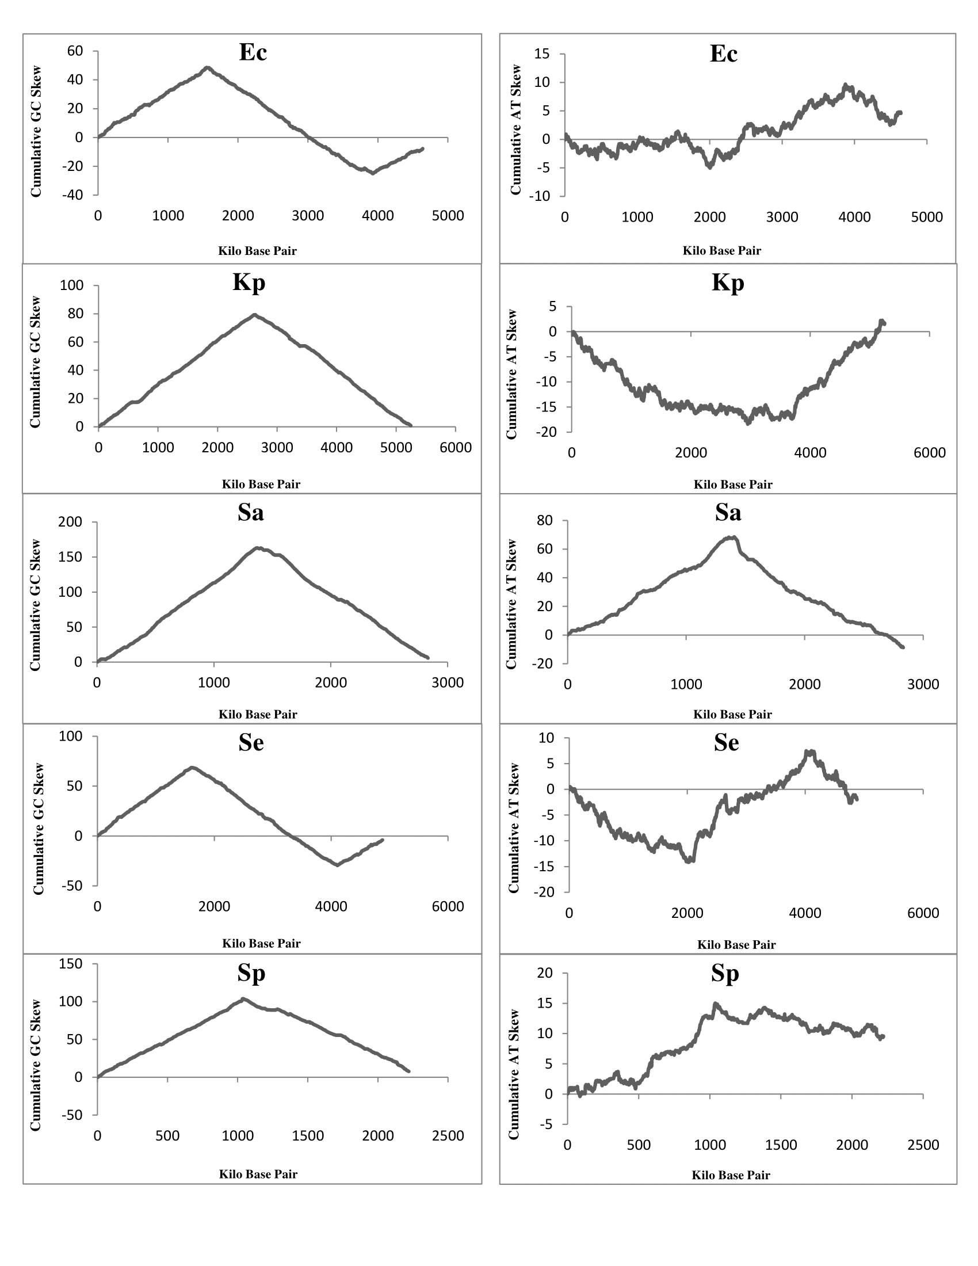

Figure represents cumulative GC and AT skew diagram of chromosomes of *Escherichia coli* (*Ec*) (MG1655)*, Klebsiella pneumoniae* (*Kp*) (NTUH_K2044)*, Salmonella enterica* (*Se*) (Typhimurium_D23580)*, Staphylococcus aureus* (*Sa*) (HO_5096_0412)*, and Streptococcus pneumoniae* (*Sp*) (ATCC_700669). Nucleotide base frequencies in non-overlapping moving windows of size 1.0 kb along a genome sequence were found out and then the cumulative GC skew and AT skew were calculated as (G-C)/(G+C) and (A-T)/(A+T) respectively. These cumulative skew diagrams helped us to estimate and separate the leading (LeS) and the lagging (LaS) strands in the genome. For example, LeS is rich in base G over base C whereas the reverse is true for the LaS. Accordingly, in the cumulative skew diagram of LeS and LaS results positive and negative slopes, respectively. The magnitudes of GC skew are more than the AT skew in the chromosomes. GC skew pattern is opposite to that of AT skew in all the chromosomes except *Sa*.

**Supplementary Figure 1b: Purine-Pyrimidine (RY) skew (left panel) and keto-amino (KM) skew (right panel) in chromosomes**

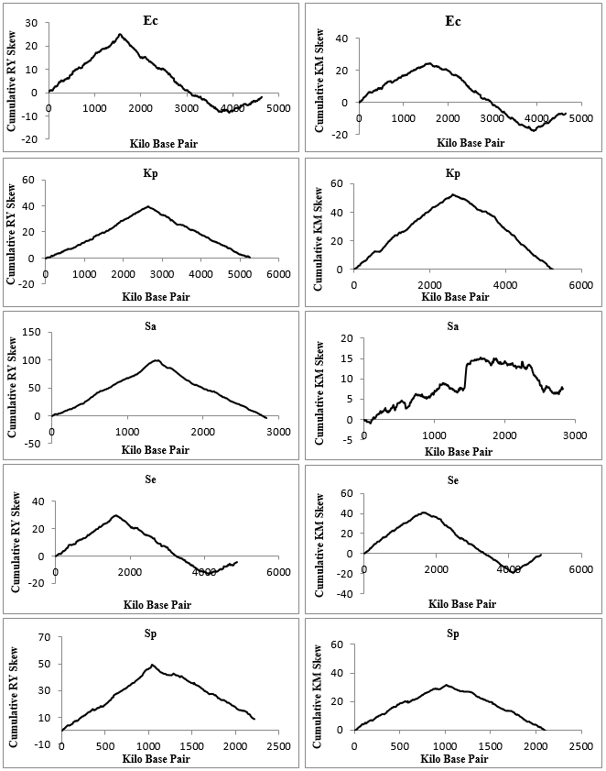

Figure represents cumulative RY and KM skew diagram of chromosomes of *Escherichia coli* (*Ec*) (MG1655)*, Klebsiella pneumoniae* (*Kp*) (NTUH_K2044)*, Salmonella enterica* (*Se*) (Typhimurium_D23580)*, Staphylococcus aureus* (*Sa*) (HO_5096_0412)*, and Streptococcus pneumoniae* (*Sp*) (ATCC_700669). Nucleotide base frequencies in non-overlapping moving windows of size 1.0 kb along a genome sequence were found out and then the cumulative RY skew and KM skew were calculated as (R-Y)/(R+Y) and (K-M)/(K+M) respectively. RY skew and KM skew with positive slope represents the leading strand and negative slope represents the lagging strand.